Shopping Cart

**To begin using the shopping cart, follow these directions:**

1. Open the index.html file in your web browser by double clicking the file 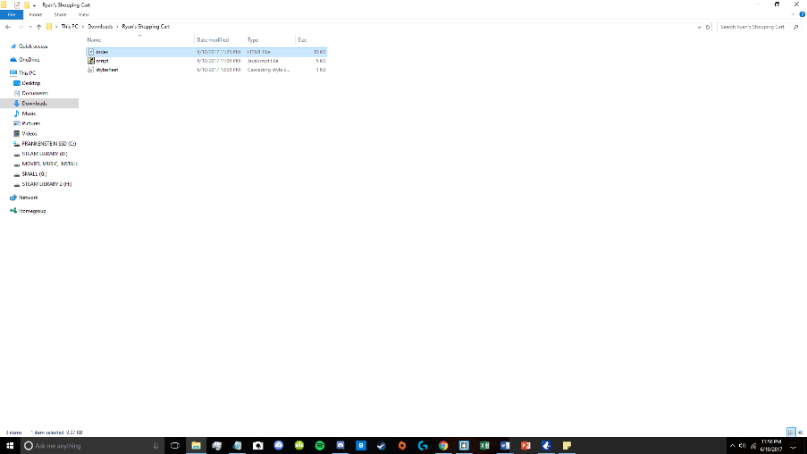
2. Use your mouse to add items to your cart by clicking on the green “Add” button 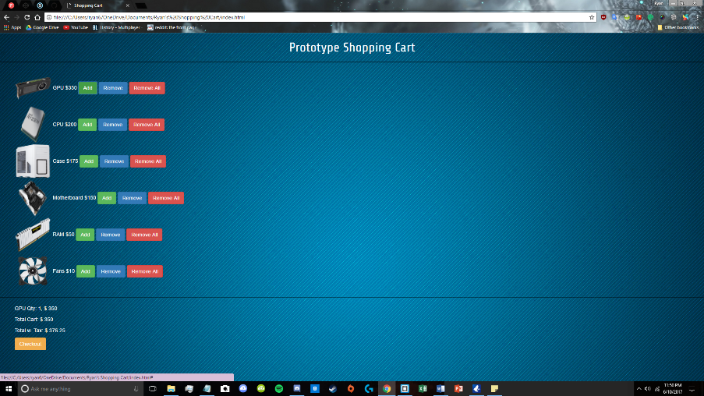
3. Remove items on an individual basis by clicking the blue “Remove” button 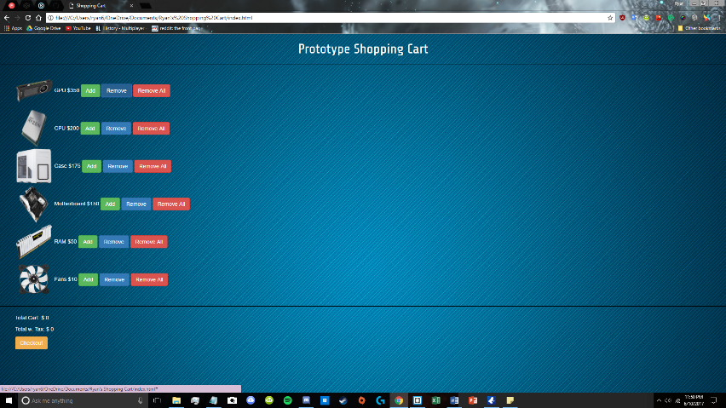
4. Remove all items of a specific kind by clicking the red “Remove All” button 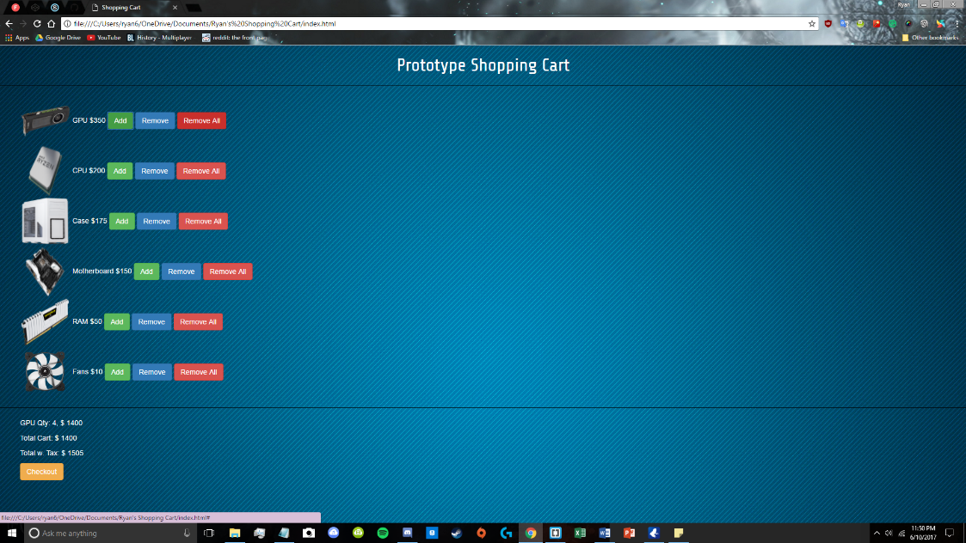 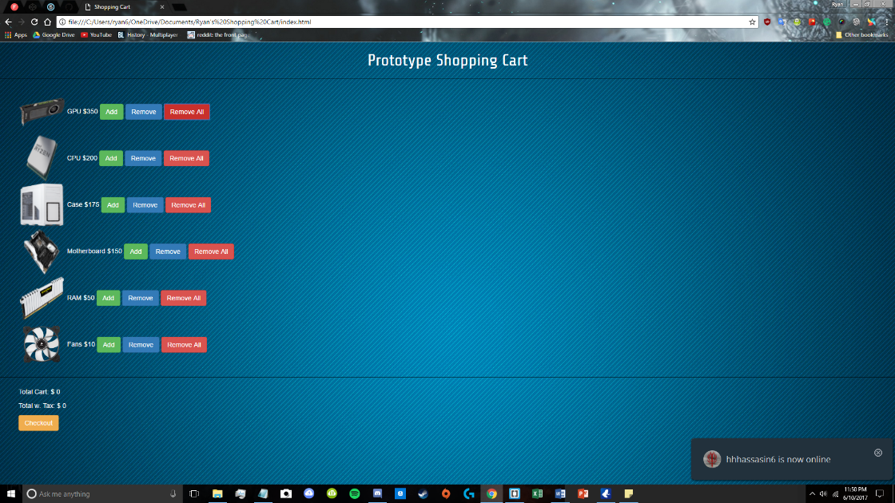
5. View the total cart cost underneath the black horizontal line 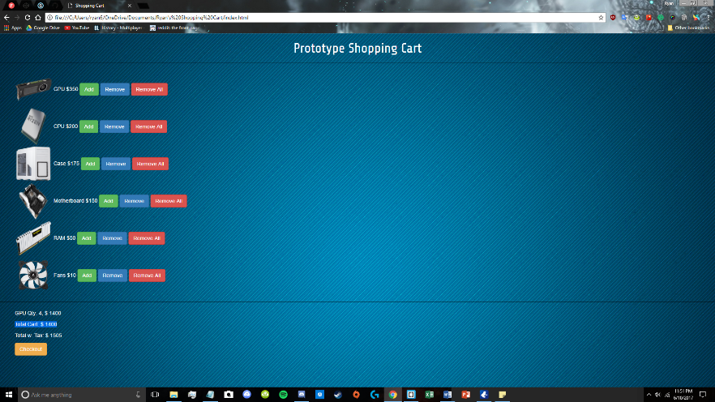
6. View the total cart cost with tax underneath the total cart cost 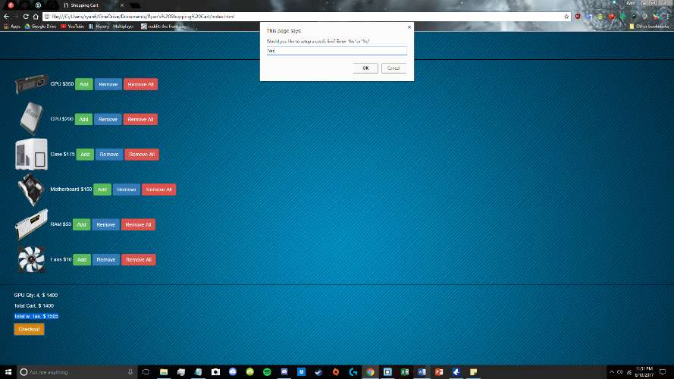
7. Click checkout to proceed with checkout 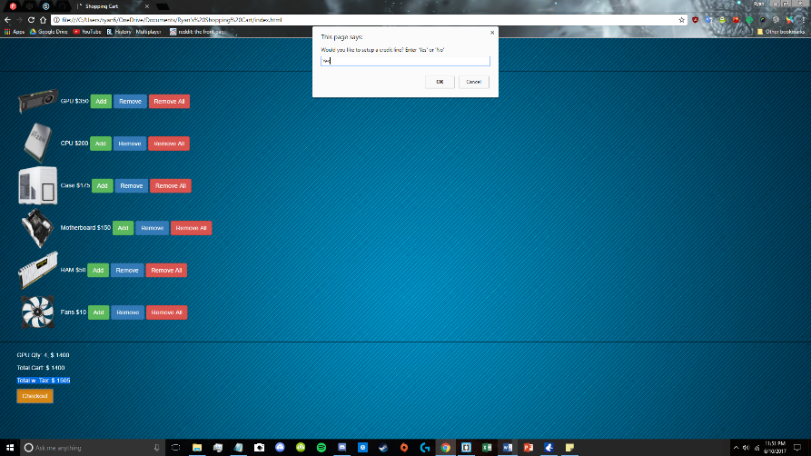

**Totals w. Tax less than $100:**

1. Click “OK” if your total with tax is less than $100 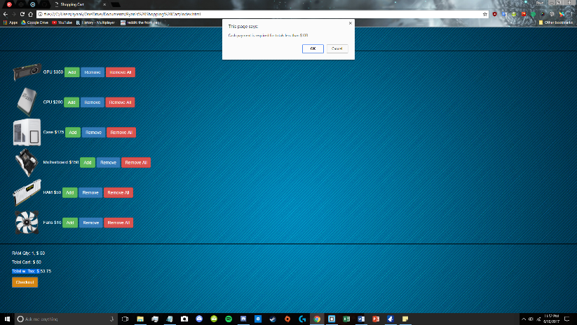

**Totals w. Tax over $100:**

1. Type “Yes” into the input field if you’d like to setup a credit line 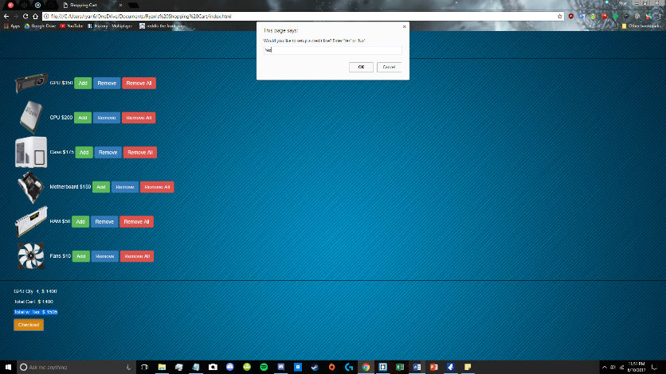
2. Click “OK” to complete 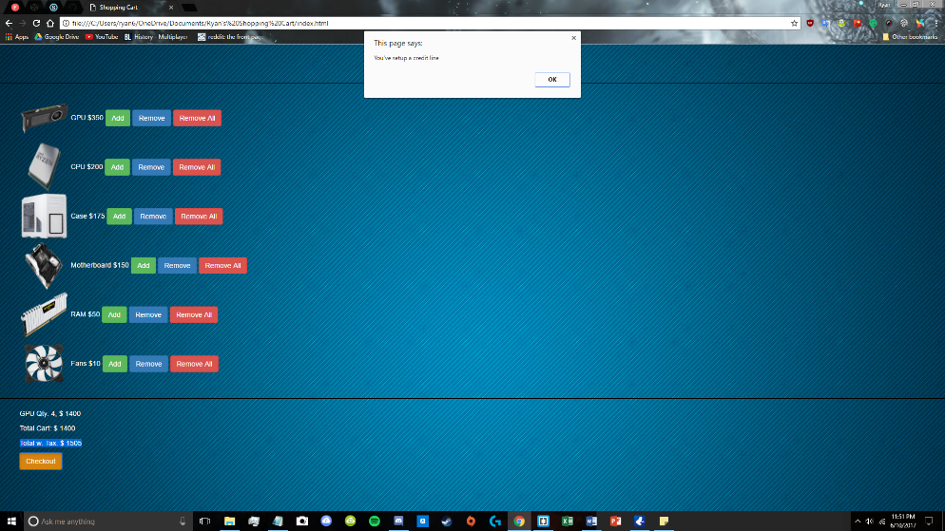

**Or**

1. Type “No” into the input field if you don’t want to setup a credit line 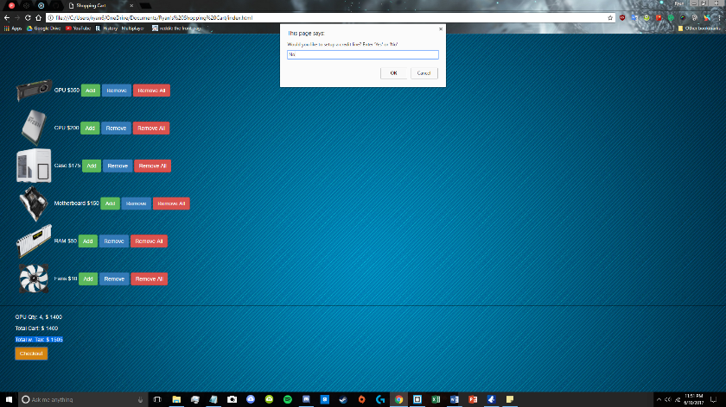
2. Click “OK” to complete 